|  |
| --- |
| EPAM Systems, RD Dep.  MTN.*NIX.07 Oracle DB. Introduction to DWH |
| MTN.*NIX.07 Labs - Star Schema Basics |

|  |  |  |  |  |  |
| --- | --- | --- | --- | --- | --- |
| REVISION HISTORY | | | | | |
| Ver. | Description of Change | Author | Date | Approved | |
| Name | Effective Date |
| 1.0 | Initial status of document | [**Kiryl Bucha**](mailto:Kiryl_bucha@epam.com) | 16-JAN-2012 |  |  |
|  |  |  |  |  |  |

*Contents*

1. Prerequisites Task 3

1.1. Passwords Index 3

1.2. Folder Paths Index 3

2. OLTP – Load External References – Normalization of Data 3

2.1. Task 01 – Install and expand load of external references T_Languages 3

2.1.1. iso-639-3.tab – Storage of Languages 3

2.1.2. iso-639-3-Macro.tab – Store of Links Between Macro and Individual languages 4

2.1.3. Installing scripts 4

2.2. Task 02 – Create load process for External references T_Countries 6

3. OLAP – Creation of document 6

3.1. Task 03 – Solution concept – Business background 6

4. OLAP – Develop Star-Scheme and SnowFlake Scheme. 6

4.1. Task 04 – Develop Star-Scheme physical diagram 6

4.2. Task 05 – Develop SnowFlake physical diagram 7

# Prerequisites Task

## Passwords Index

|  |  |  |
| --- | --- | --- |
| Password Group | Login Name | Password |
| Operation System | root | “rootadmin” |
|  | oracle | “oracleadmin” |
|  |  |  |
| Oracle System | sys | “sysadmin” |
|  | system | “sysadmin” |
|  |  |  |
| Oracle Users | All DB users | “%PWD%” |
|  |  |  |
|  |  |  |

## Folder Paths Index

|  |  |  |
| --- | --- | --- |
| Path Group | Path Description | Path |
| Operation System | Oracle RDBMS – BIN | /oracle/app/oracle |
|  | Oracle Inventory | /oracle/app/oraInventory |
|  | Oracle Database Storage | /oracle/oradata |
|  | Oracle Install Directory | /oracle/install |
| Oracle | ORACLE_BASE | /oracle/app/oracle |
|  | ORACLE_HOME | $ORACLE_BASE/product/11.2 |
|  |  |  |
| FTP | ftp Incoming Folder | **/ftp/incoming** |
|  |  |  |
|  |  |  |

# OLTP – Load External References – Normalization of Data

## Task 01 – Install and expand load of external references T_Languages

Description of External Resources:

|  |  |
| --- | --- |
| File Name | Path |
| iso-639-3.tab | …\Topic 06 - Star Schema Basics\External_References |
| iso-639-3-Macro.tab | …\Topic 06 - Star Schema Basics\External_References |

### iso-639-3.tab – Storage of Languages

|  |  |  |
| --- | --- | --- |
| Name | Data Type | Comment |
| lng_3c_code | VARCHAR2( 3 CHAR ) | ISO 639-3 identifier |
| lng_2b_code | VARCHAR2( 3 CHAR ) | ISO 639-2 identifier of the bibliographic applications |
| lng_2t_code | VARCHAR2( 3 CHAR ) | ISO 639-2 identifier of the terminology applications code |
| lng_1c_code | VARCHAR2( 2 CHAR ) | ISO 639-1 identifier - common standard |
| lng_scope | VARCHAR2( 2 CHAR ) | Identifier of the language scope |
| lng_type | VARCHAR2( 1 CHAR ) | Identifier of the language type |
| lng_desc | VARCHAR2(200 CHAR) | Edonym Name of Language |

### iso-639-3-Macro.tab – Store of Links Between Macro and Individual languages

|  |  |  |
| --- | --- | --- |
| Name | Data Type | Comment |
| macro_lng_code | VARCHAR2(3 CHAR) | LNG_ID: MacroLanguage - T_Languages |
| indiv_lng_code | VARCHAR2(3 CHAR) | LNG_ID: Individual Language - T_Languages |

### Installing scripts

Path: …\Topic 06 - Star Schema Basics\lab_scripts\task01\

|  |  |  |
| --- | --- | --- |
| Path: | Folder | Description |
| ../ lab_scripts/task01 |  |  |
|  | /system | All system admin scripts:   * Initial Tablespaces scripts * Initial Users scripts |
|  | /u_dw_common | Store common used objects |
|  | /u_dw_references | Store of DB references objects |
|  | /u_dw_ext_references | Cleansing store for External References |

**The Main Task** is to running preparing SQL scripts and install needed objects for load external reference T_Languages.

**Task Results:**

* Create sql scripts to show All created Tables and Views – Screenshot

SELECT Table_NAME, OWNER

FROM SYS.ALL_TABLES

WHERE OWNER IN ('U_DW_COMMON', 'U_DW_REFERENCES', 'U_DW_EXT_REFERENCES')

UNION

SELECT VIEW_NAME, OWNER

FROM SYS.ALL_VIEWS

WHERE OWNER IN ('U_DW_COMMON', 'U_DW_REFERENCES', 'U_DW_EXT_REFERENCES')

ORDER BY OWNER

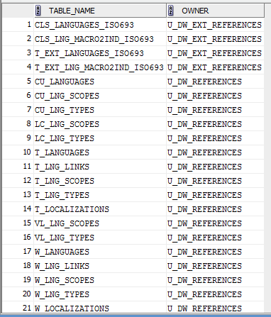

* Create DataFlow: Sketch Diagram of loading external References (MS Visio, MS Paint, MS Word, etc.)

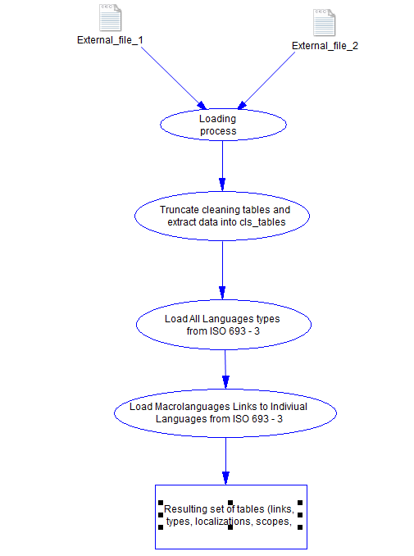

* Create sql: Showing result of data on next objects:
  + t_localizations

select * from t_localizations;

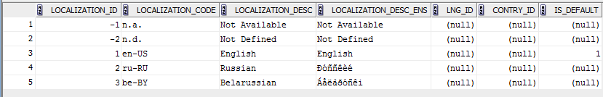

* + cu_languages

select * from cu_languages;

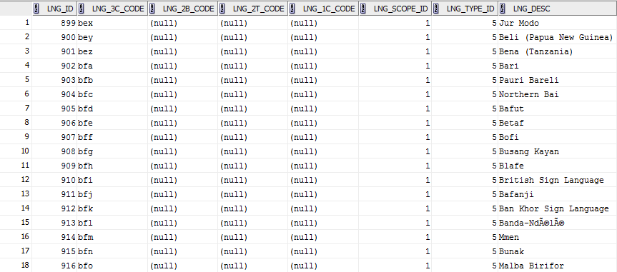

* + w_lng_links

select * from w_lng_links;

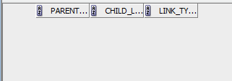

* + cu_lng_scopes

select * from cu_lng_scopes;

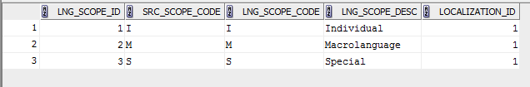

* + cu_lng_types

select * from cu_lng_types;

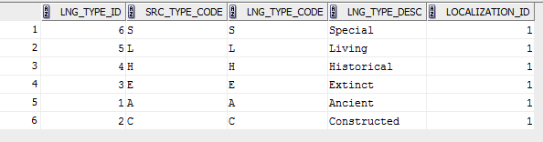

The Physical Diagram of T_Languages below:

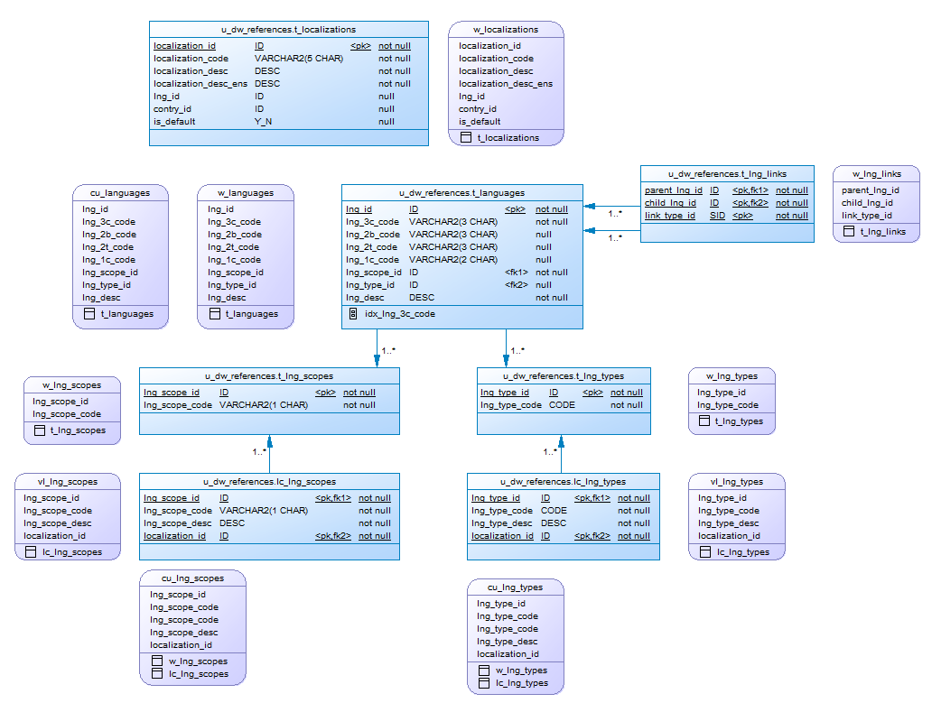

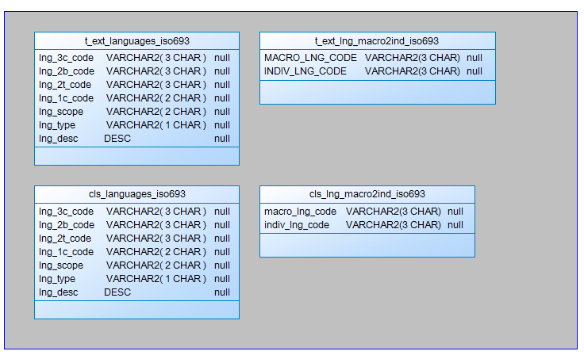

## Task 02 – Create load process for External references T_Countries

Description of External Resources:

|  |  |
| --- | --- |
| File Name | Path |
| iso_3166.tab | …\Topic 06 - Star Schema Basics\External_References |
| iso_3166_geo_un.tab | …\Topic 06 - Star Schema Basics\External_References |
| iso_3166_geo_un_contries.tab | …\Topic 06 - Star Schema Basics\External_References |
| iso_3166_groups_un.tab | …\Topic 06 - Star Schema Basics\External_References |
| iso_3166_groups_un_contries.tab | …\Topic 06 - Star Schema Basics\External_References |

**The Main Task** is to develop SQL scripts and install needed objects for load external reference T_Countries.

**Task Results:**

* Create SQL scripts to show All created Tables and Views – Screenshot

SELECT Table_NAME, OWNER

FROM SYS.ALL_TABLES

WHERE OWNER IN ('U_DW_COMMON', 'U_DW_REFERENCES', 'U_DW_EXT_REFERENCES')

UNION

SELECT VIEW_NAME, OWNER

FROM SYS.ALL_VIEWS

WHERE OWNER IN ('U_DW_COMMON', 'U_DW_REFERENCES', 'U_DW_EXT_REFERENCES')

ORDER BY OWNER

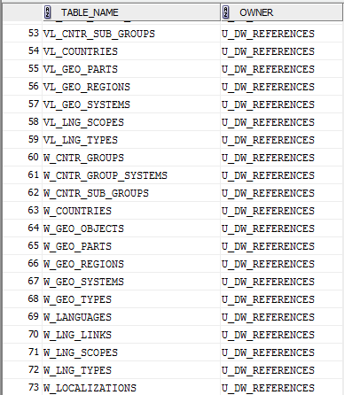

* Create DataFlow: Sketch Diagram of loading external References (MS Visio, MS Paint, MS Word, etc.)

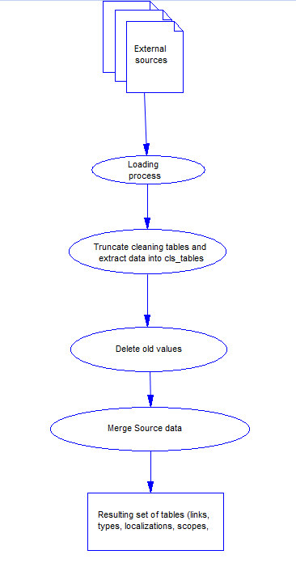

* Create SQL: Showing result of data on main objects:

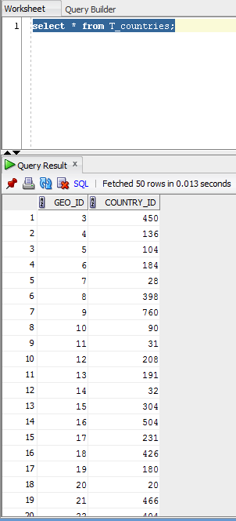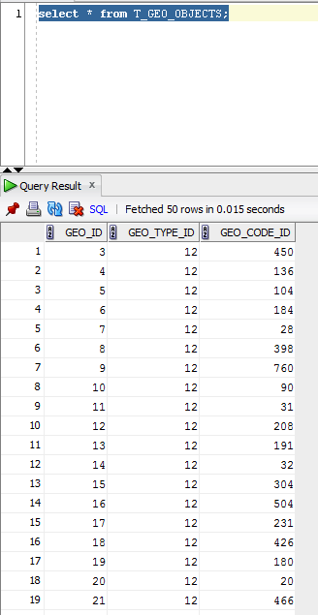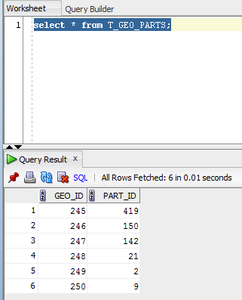

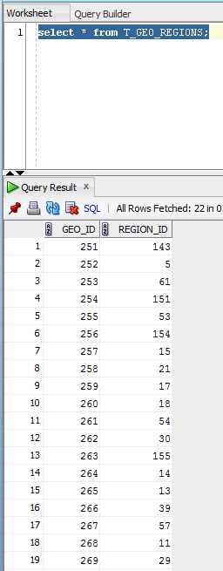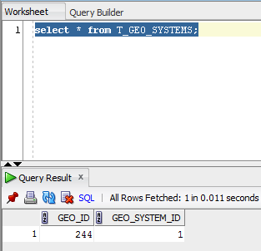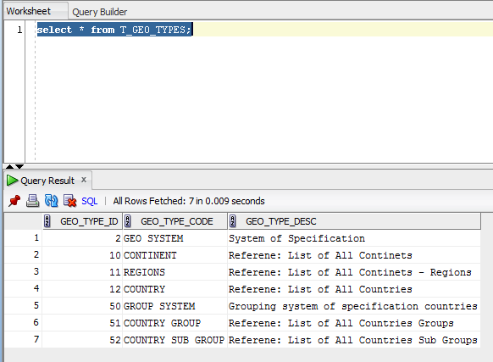

* Prepare The Physical Diagram of T_Countries

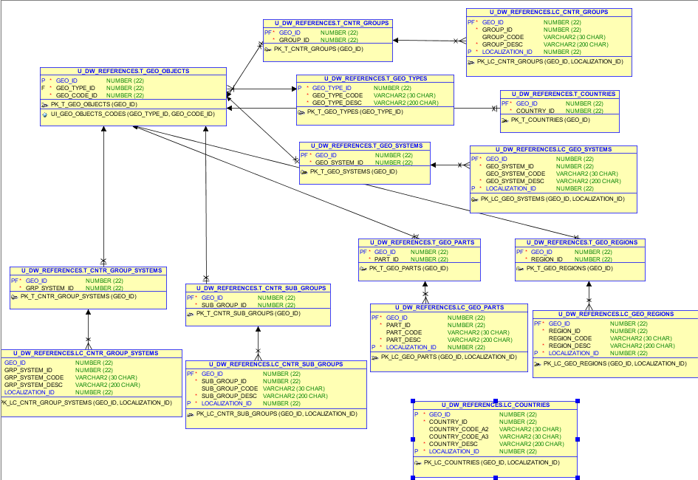

# OLAP – Business analyses task

Create any business analyses task for interesting for your business. The main idea is to use next main dimension:

* Time
* Geo-Location – T_COUNTRIES

## Task 03 – Solution concept – Business background

**The Main Task** is to create Solution concept of yours any business analyses task. You should use Developing Model, that described on MTN.NIX.07.Oracle DB.DWH_courseware06_Star Schema Basics.docx.

**Task Results:**

Create Solution Concept document, which contained next chapters:

Overview

Business Background

Benefit

Requirements

Business Requirements

Technical Requirements

Solution Sketch

Source Tables structure

Summarize Data Plan

# OLAP – Develop Star-Scheme and SnowFlake Scheme.

## Task 04 – Develop Star-Scheme physical diagram

**The Main Task** is to create Star Physical diagram and Logical diagram of solution.

**Task Results:**

Create document, which contained next chapters:

* + Physical diagram

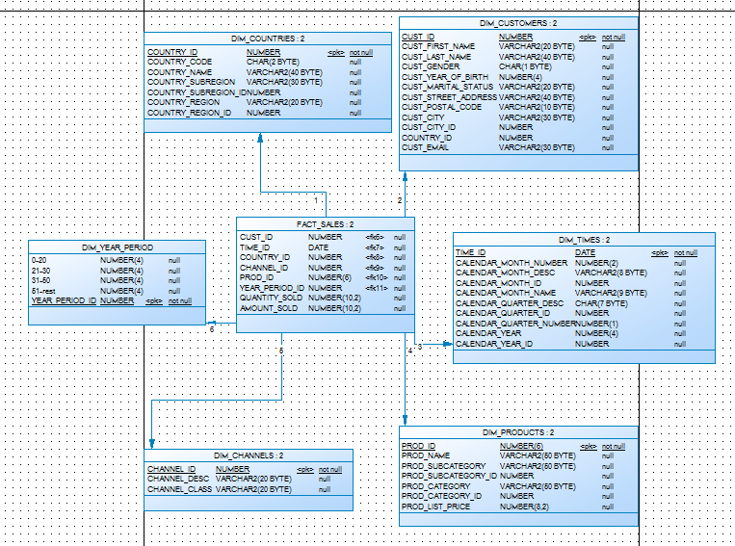

* + Logical diagram

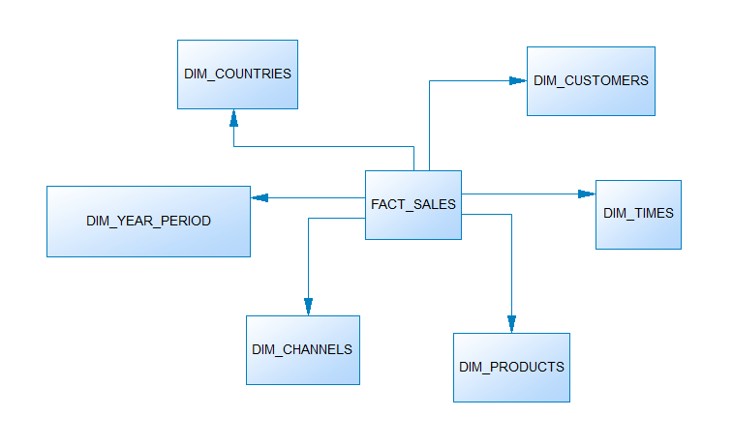

## Task 05 – Develop SnowFlake physical diagram

**The Main Task** is to create SnowFlake Physical diagram and Logical diagram of solution.

**Task Results:**

Create document, which contained next chapters:

* + Physical diagram

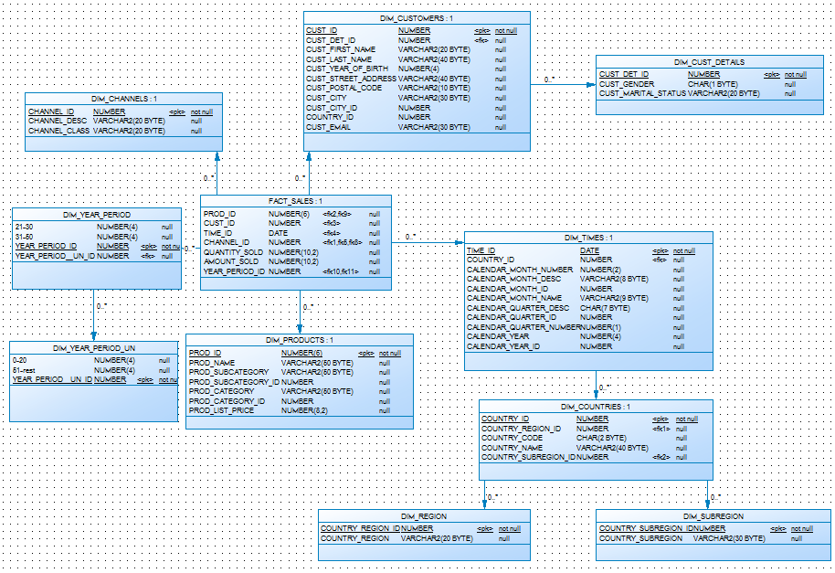

* + Logical diagram

